UniversityRS

# User manual

Welcome to the UniversityRS user manual. We hope the information provided here will assist you in using UniversityRS.

Table of Contents

User manual 1

Chapter 01: Introdcution to UniversityRS 5

About university RS 5

Feature List 5

System Requirements 6

Chapter 02: Basic Guide 7

Login 7

Restoring Password 8

Registering on the Application 9

User Profile Management 10

Change Profile Picture 10

Changing Name 11

Changing Password 11

User Management 12

Add a new Authorized user 12

Edit an Authorized user 13

Delete an Authorized user 13

Edit a Registered user 14

Delete a Registered User 15

Resource Management 16

Add a Resource 16

Edit a Resource 17

Delete a Resource 17

View Timetable for a Resource 18

Subject Management 19

Add a Subject 19

Edit a Subject 20

Delete a Subject 20

Batch Management 21

Add a Batch 21

Edit A Batch 23

Delete A Batch 23

Timetable Management 24

View A Batch Timetable 24

Semester Request Management 25

View Semester Requests 25

Approve A Semester Request 25

Delete A Semester Request 27

Formal Request Management 28

View Formal Requests 28

Approve A Formal Request 28

Delete A Formal Request 30

Special Event Request Management 31

View Special Event Requests 31

Approve A Special Event Request 32

Delete A Special Event Request 33

Timetable Management 34

View Timetable 34

Requests 35

Adding a Formal Request 35

Editing a Formal Request 36

Deleting a Formal Request 37

Adding a Special Request 37

Editing a Special Request 38

Deleting a Special Request 39

Adding a Semester Request 39

Editing a Semester Request 40

Deleting a Semester Request 41

Viewing Requests. 41

Timetable 42

View Timetable 42

Exporting Timetable as Excel Sheet 43

Exporting Timetable as PDF 43

Chapter 03: Advanced Guide 44

Assign Deadlines 45

Add a Deadline 45

Delete a deadline 46

Options 46

Enable Semester Request form 46

Completely Clear Timetable 47

completely Clear Timetable (Custom) 48

Database Backup 49

Database Restore 49

Master Reset 51

# Chapter 01: Introdcution to UniversityRS

This chapter provides a quick overview of UniveristyRS, presenting its main features and system requirements.

## About university RS

University Resource Scheduler is an online web application designed for Sri Lanka Institute of Information Technology as a solution for manual data storing which enables the user to manage resources effectively within the university. The application facilitates the users to keep all information about the resources (i.e.: Lecture halls and Labs) and maintain a timetable for the particular resource. The application handles two type of users, Administrator and staff member. Staff members can get registered in the site using the relevant information they are provided with and make requests for resources at the beginning of the semester or request special slots throughout the semester. These requests are supervised by the administrator and allocates resources to the users based on their priority. The application provides an effective environment and manages all the other tasks to enable users to communicate and ease their day to day work.

## Feature List

**Administrative Section**

* User Management
  + Authorized User Management.
  + Registered User Management.
* Request Management
  + Formal Request Management.
  + Semester Request Management.
  + Special Event Request Management.
* Resource Management
  + Generate Timetable.
* Subject Management
* Profile Management
* Batch Management
* Timetable Management
* Administrator Settings

**User Section**

* Requesting for Lecture Halls or Labs.
* View Timetable

## System Requirements

* 512MB minimum RAM
* Web Browser
* Internet Connection

# Chapter 02: Basic Guide

### Login

During the first initialization the user must login using the default user credentials, which is personally handed over to the user. And then change or add new users to the system.

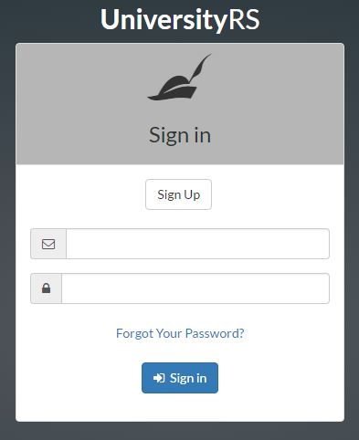

When the user logs in the home screen will be the first screen displayed to the user. From there user can perform the following operations.

### Restoring Password

1. Click on ‘*Forgot Your Password’.*
2. Enter the email address you are registered with.

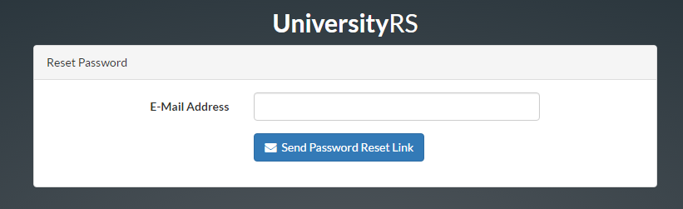

1. Click ‘*Send Password Reset Link’*.

You will receive an Email contain a link to reset the password. Once you click the link you will be redirected to a form to enter your new password.

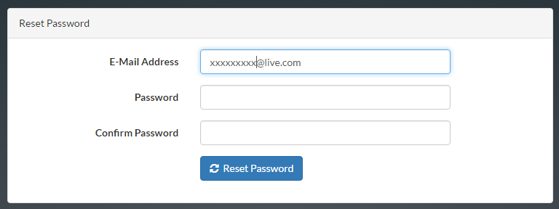

Once you reset your password you will be redirected to the home page depending on your priority level.

### Registering on the Application

1. Click on ‘*Sign Up* ‘*.* On the login screen

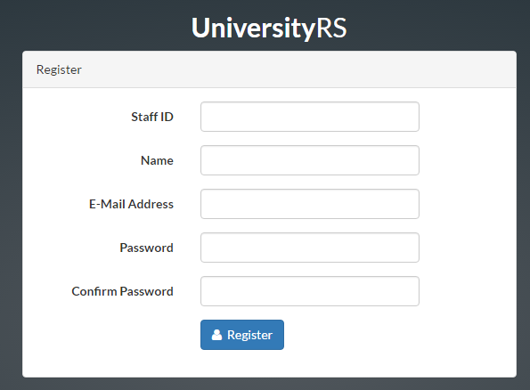

1. Enter the data provided by the administrator.
2. Click ‘*Register* ‘

Once you Register you will be redirected to the home page based on you Authorization level.

### User Profile Management

The user profile can be managed by clicking the ‘Username’ and clicking ‘Profile’ button.

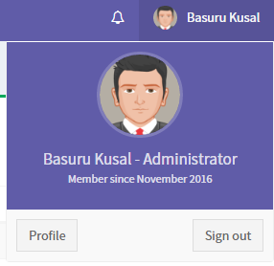

### Change Profile Picture

1. Visit the profile section.
2. Click the ‘Gear’ Icon next to profile picture box and select ‘Change Picture’

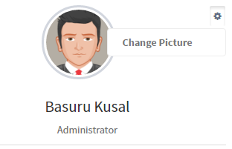

1. Select a picture and click ‘*Upload Picture’.*

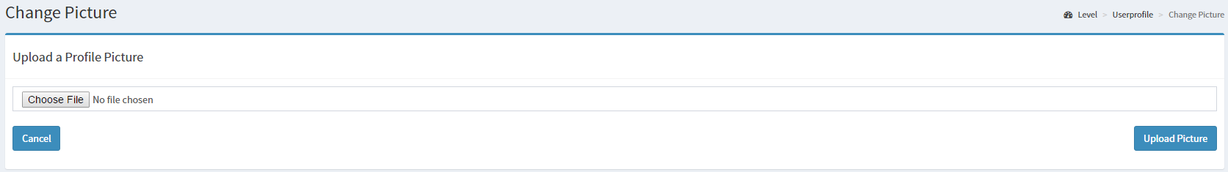

### Changing Name

1. Visit Profile section.
2. Type a new name in the Name test field.

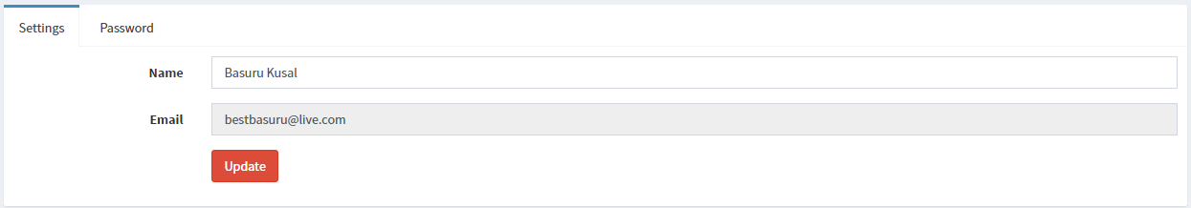

1. Click ‘*Update’.*

### Changing Password

1. Visit Profile section.
2. Click ‘*Password’* Tab.
3. Type the old password, New password and Confirmed new password.

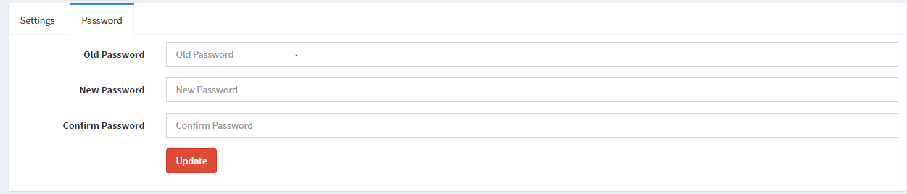

1. Click ‘*Update’.*

Administrative Section.

## User Management

### Add a new Authorized user

1. Click ‘*More info*’ available under User Management.
2. Enter staff id and select a priority level.

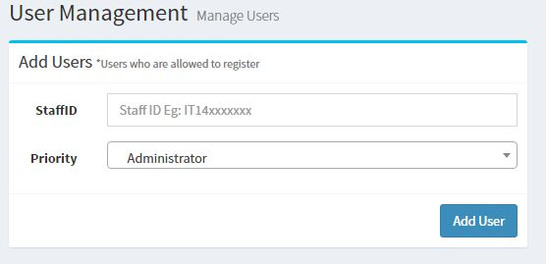

1. Click ‘*Add User’* button.

Once you added a record it will be displayed in the **Authorized Users** table.

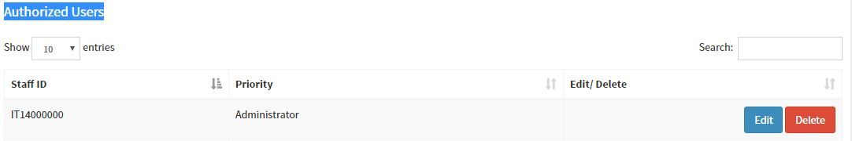

### Edit an Authorized user

1. Click ‘*Edit’* button of relevant to record.



1. Click ‘*Yes’* on the alert message.

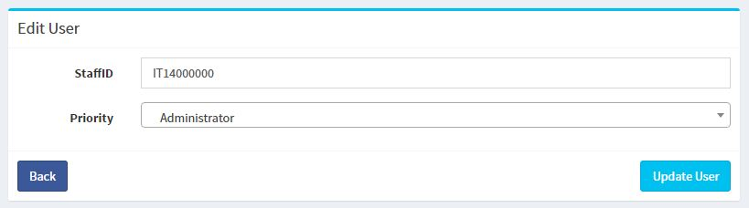

1. Edit the necessary details as desired.
2. Click ‘*Update User’* button.

Note that if you change the priority level of an already registered user then his priority level will also be changed.

### Delete an Authorized user

1. Click ‘*Delete’* button of relevant to record.



1. Click ‘*Yes’* on the alert message.

Note that if you delete an already registered user in the authorized users table then the user details relevant to the user in Registered user table will also be deleted making the user unable to login to the application.

### Edit a Registered user

1. Click ‘*Edit’* button of relevant to record.

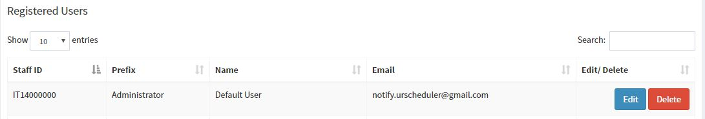

1. Click ‘*Yes’* on the alert message.
2. Edit the necessary details as desired.

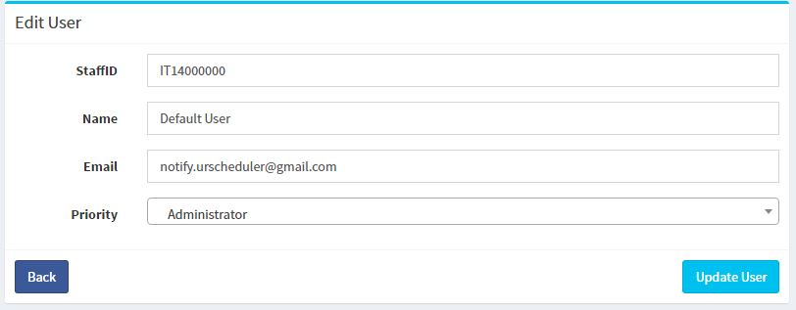

1. Click ‘*Update User’* button.

### Delete a Registered User

1. Click ‘*Delete’* button of relevant to record.



1. Click ‘*Yes’* on the alert message.

## Resource Management

Resources are categorized in to two sections which are Lecturer Halls and Labs. A user can keep updated records of each Lecture Hall and Lab. Also a user can view the timetable allocated to a particular resource.

### Add a Resource

1. Click ‘*More info*’ available under Resource Management.
2. Enter Hall no, Capacity, and select a Resource type.

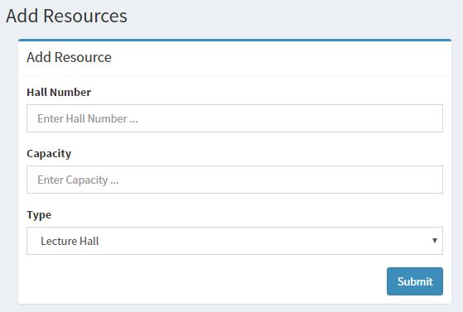

1. Click ‘*Submit’* button.

Once you add a resource it will be displayed on the Resources table.

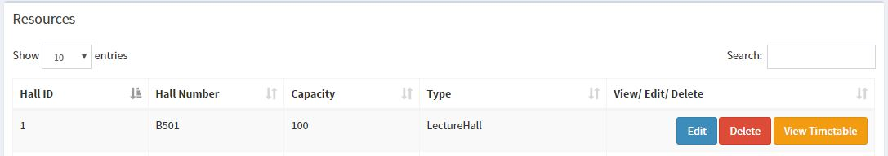

### Edit a Resource

1. Click ‘*Edit’* button of relevant to record.



1. Click ‘*Yes’* on the alert message.
2. Edit the necessary details as desired.

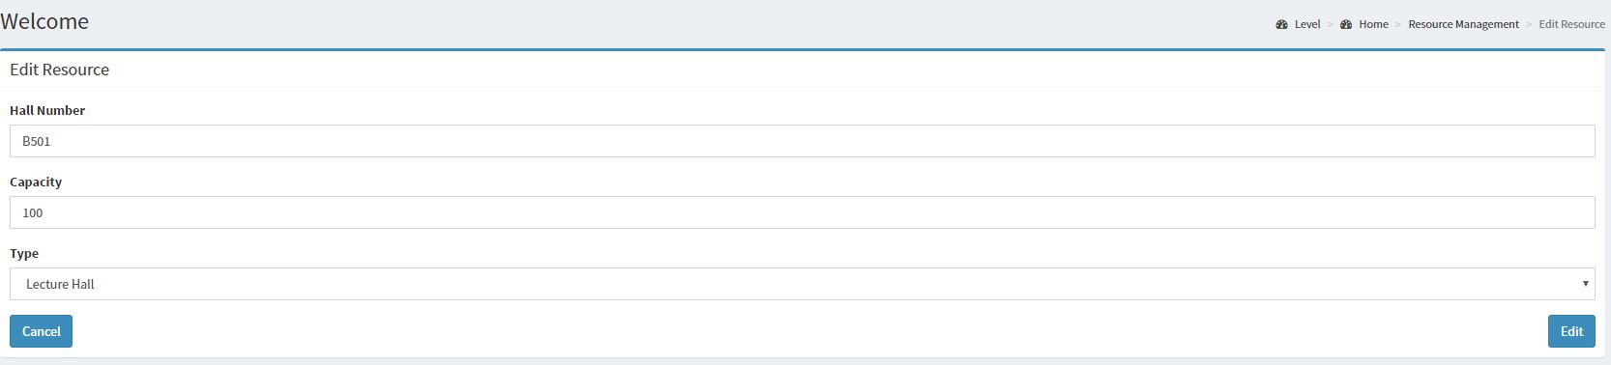

1. Click ‘*Edit*’button.

### Delete a Resource

1. Click ‘*Delete’* button of relevant to record.



1. Click ‘*Yes’* on the alert message.

Note that if you try to delete a resource which is being allocated to a Lecture Hall or Lab then the user cannot delete it. An Error message will be shown to the user indicating this.



### View Timetable for a Resource

1. Click ‘*View Timetable’* button of relevant to record.



## Subject Management

A user can keep records of all the subjects that are being taught in the university along with the details of which year and semester a particular subject belongs to.

### Add a Subject

1. Click ‘*More info*’ available under Subject Management.
2. Enter Subject code, Subject Name, Year and Semester.



1. Click ‘*Add’* button.

Once you add a resource it will be displayed on the Subjects table.



### Edit a Subject

1. Click ‘*Edit’* button of relevant to record.



1. Click ‘*Yes’* on the alert message.
2. Edit the necessary details as desired.

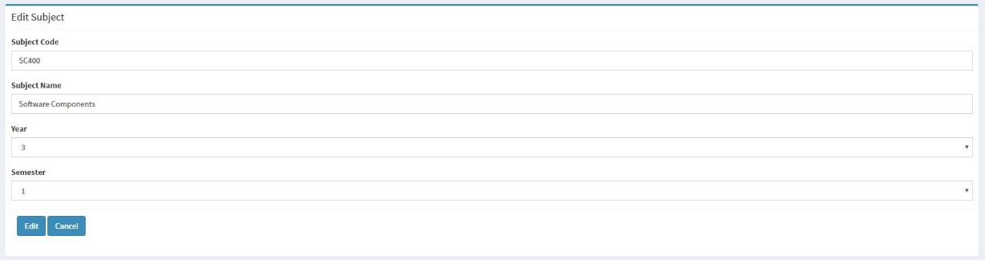

1. Click ‘*Edit*’button.

### Delete a Subject

1. Click ‘*Delete’* button of relevant to record.



1. Click ‘*Yes’* on the alert message.

## Batch Management

A user can keep details of the batches, which contains Batch no, No of students, Year and Batch type (Weekend or weekday).

### Add a Batch

1. Click ‘*More info*’ available under Batch Management.
2. Enter Batch No, No of Students, Year and select a batch type.



1. Click ‘*Add Batch’* button.

Once you add a resource it will be displayed on the Batches table.

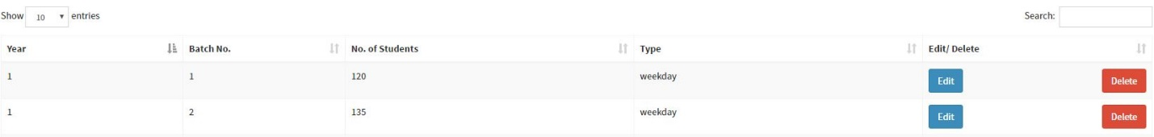

### Edit A Batch

1. Click ‘*Edit’* button of the relevant record.



1. Click ‘*Yes’* on the alert message.
2. Edit the necessary details as desired.



1. Click ‘*Edit*’button.

### Delete A Batch

1. Click ‘*Delete’* button of relevant to record.



1. Click ‘*Yes’* on the alert message.

## Timetable Management

The administrator will be able to view the semester timetable of a batch.

### View A Batch Timetable

1. Click ‘*More info*’ available under Timetable Management.
2. Select the Year and the Batch Number.

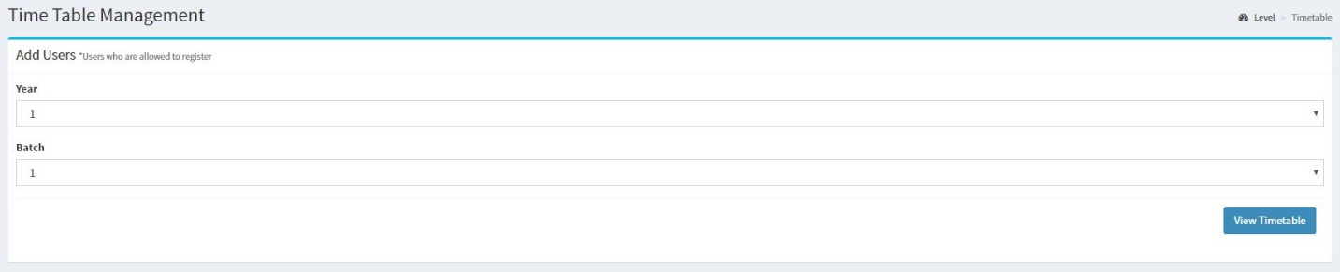

1. Click ‘*View Timetable’* button.

Once you have completed the above steps, you will be displayed the generated timetable.

## Semester Request Management

The administrator is able to view the pending Semester Request, accepted Semester Requests and also able to approve Pending Requests.

### View Semester Requests

1. Click ‘*More info*’ available under Request Management.
2. Click on ‘*View Semester Request*’.

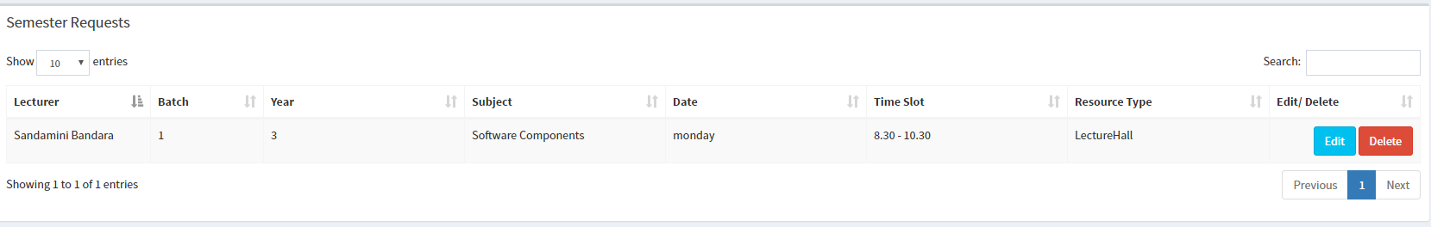

### Approve A Semester Request

1. Click ‘*Edit*’ button, which is available in front of the desired request.



1. Click ‘*Yes’* on the alert message.
2. Select a Resource to be assigned.

(In the event where no resources are available, the administrator must choose a different timeslot or a day.)

These requests are sorted by the priority level of the requesting user.

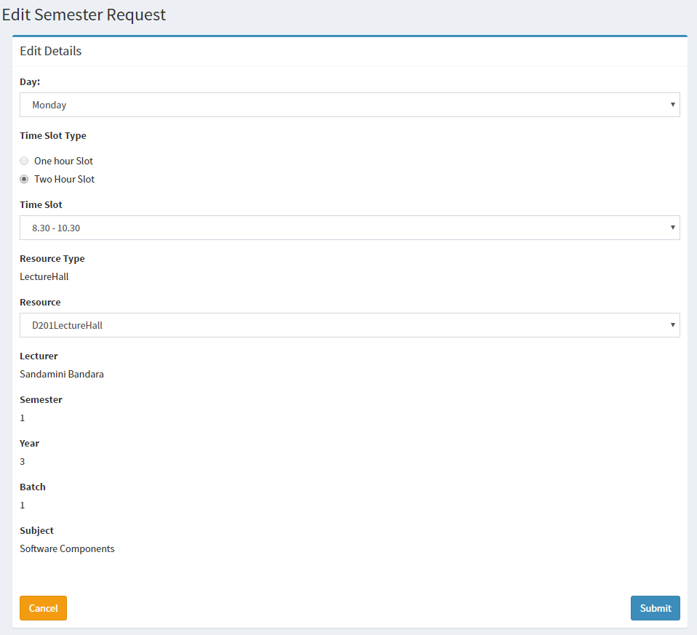

Once the Semester Request was successfully approved, you will be able to see it under the Accepted Semester Request table as shown below.

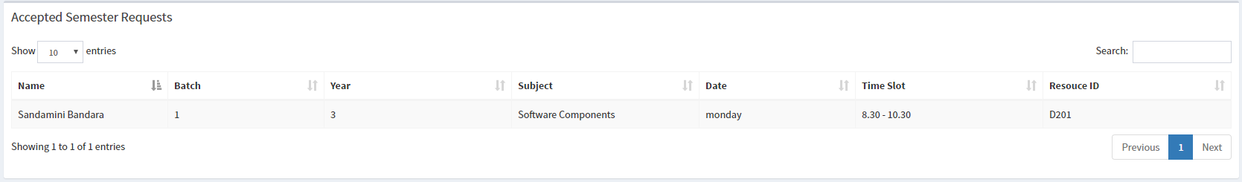

### Delete A Semester Request

1. Click ‘*Delete’* button of relevant to record.



1. Click ‘*Yes’* on the alert message.

## Formal Request Management

The administrator is able to view the pending Formal Requests, accepted Formal Requests and also able to approve Pending Formal Requests.

### View Formal Requests

1. Click ‘*More info*’ available under Request Management.
2. Click on ‘*View Formal Request*’.

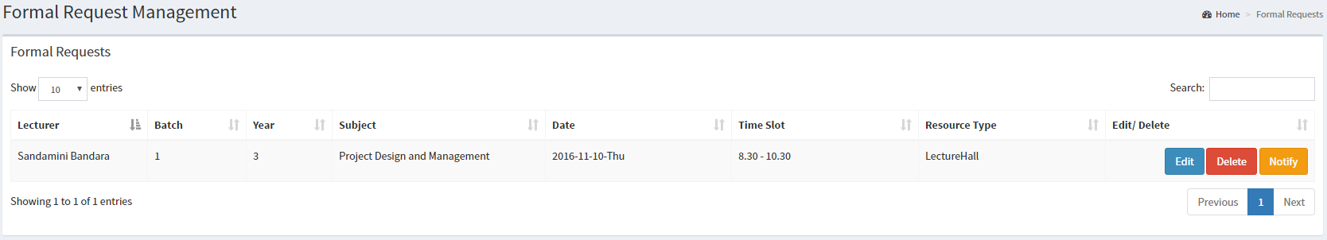

### Approve A Formal Request

1. Click ‘*Edit*’ button, which is available in front of the desired request.
2. Click ‘*Yes’* on the alert message.

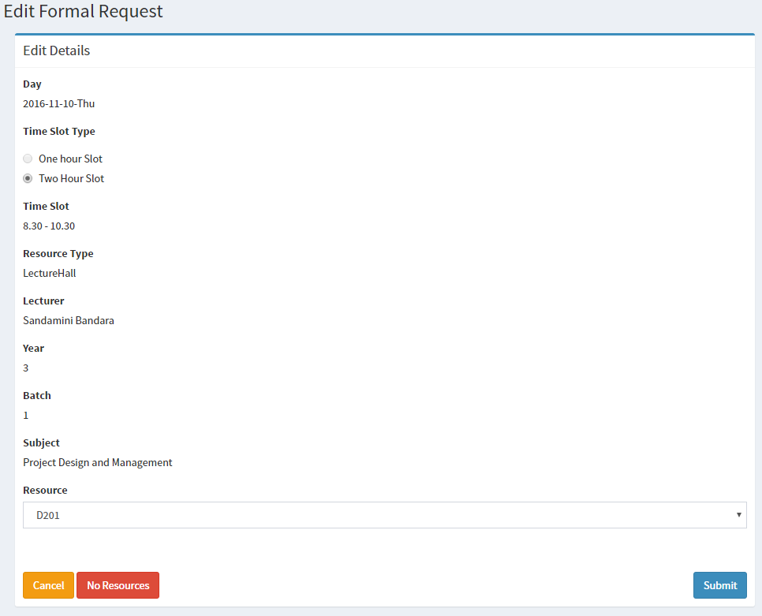

1. Select a Resource to be assigned.

(In the event where no resources are available, the administrator must choose a different timeslot or a day.)

Once the Formal Request was successfully approved, you will be able to see it under the Accepted Formal Request table as shown below.

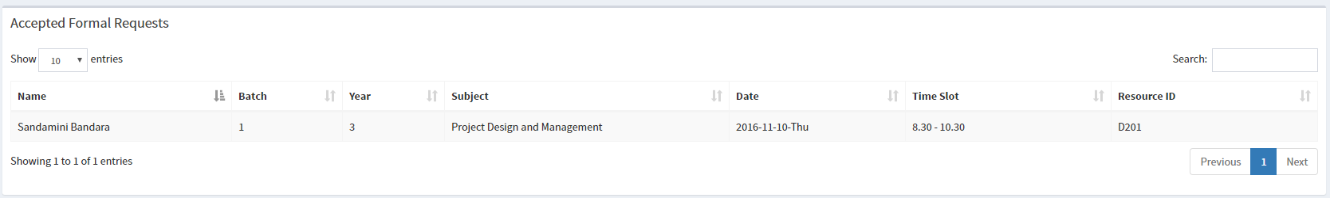

### Delete A Formal Request

1. Click ‘*Delete’* button of relevant to record.



1. Click ‘*Yes’* on the alert message.

## Special Event Request Management

The administrator is able to view the pending Special Event Requests, accepted Special Event Requests and also able to approve Pending Special Event Requests.

### View Special Event Requests

1. Click ‘*More info*’ available under Special Event Request Management.
2. Click on ‘*View Special Request*’.

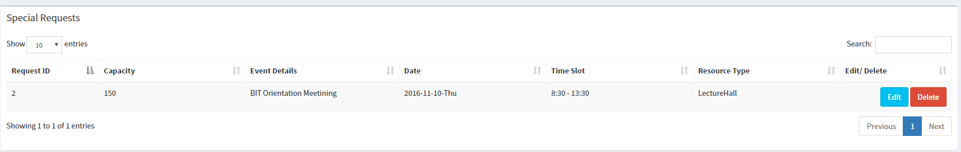

### Approve A Special Event Request

1. Click ‘*Edit*’ button, which is available in front of the desired request.
2. Click ‘*Yes’* on the alert message.
3. Select a Resource to be assigned.

(In the event where no resources are available, the administrator must choose a different timeslot or a day.)

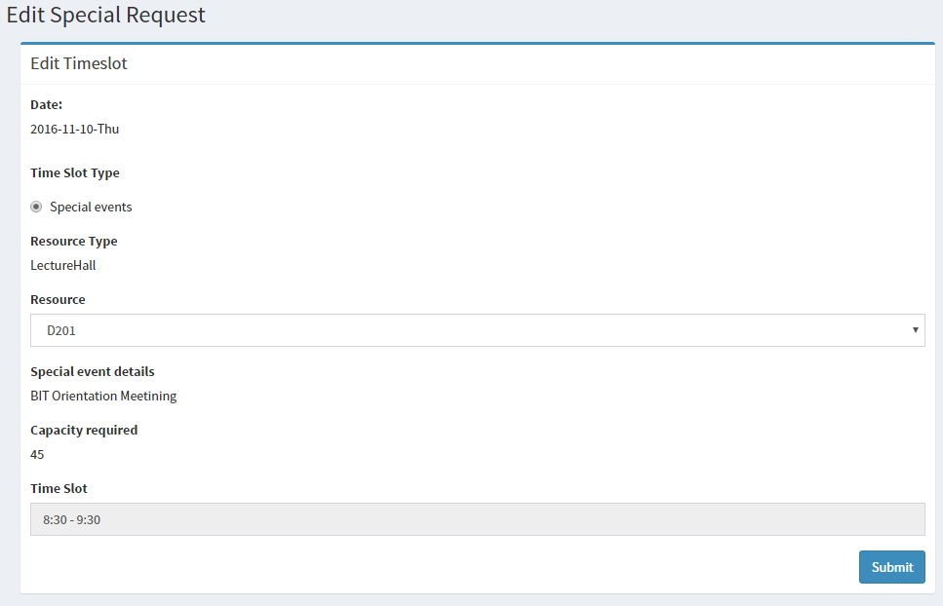

Once the Special Event Request was successfully approved, you will be able to see it under the Accepted Special Event Request table as shown below.



### Delete A Special Event Request

1. Click ‘*Delete’* button of relevant to record.



1. Click ‘*Yes’* on the alert message.

## Timetable Management

An Administrator can view the timetables of all the batches using this function. Note that this function is both visible to the Administrator and the normal User.

### View Timetable

1. Click ‘*More info*’ available under Timetable Management.
2. Select a Year and a Batch.

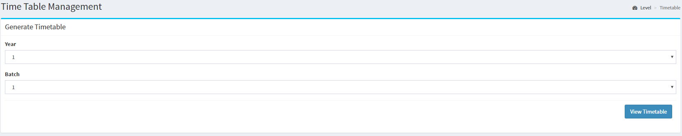

1. Click on ‘*View Timetable*’.

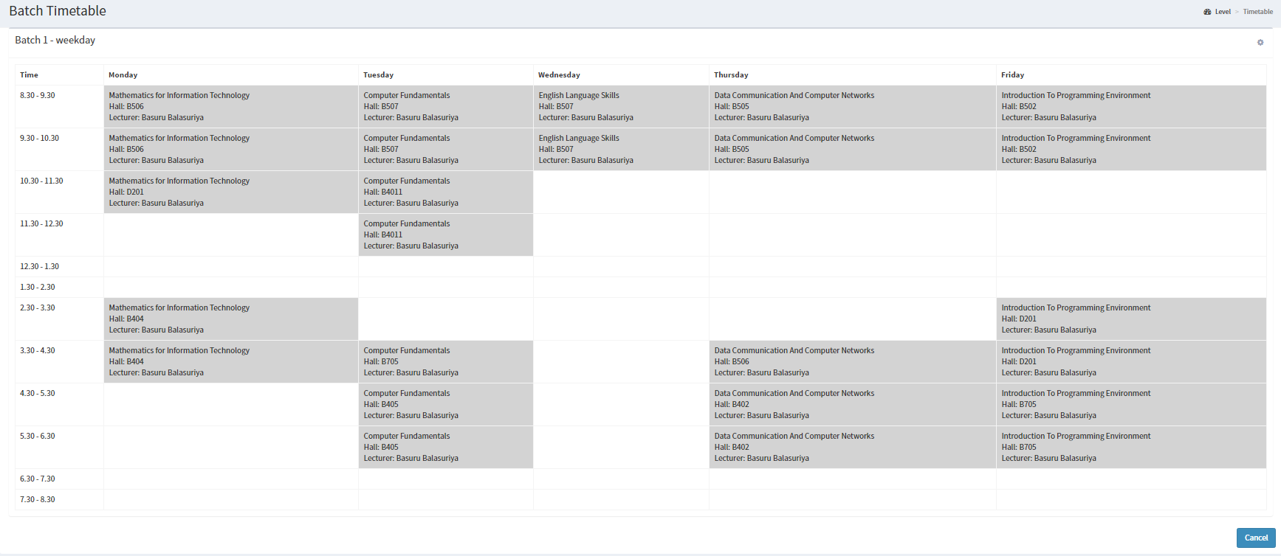

User Section.

User section can be accessed only by staff members who are not administrators.

## Requests

Requests are divided in to 3 categories,

1. Formal Requests – Requests that a performed apart from Semester Requests. Can be requested any time during a year.
2. Special Requests – Requests, requesting for non-academic purposes.
3. Semester Requests – Requests placed at the beginning of the semester. Also used in creating Timetables.

### Adding a Formal Request

1. Click ‘*More info*’ under Requests section.
2. Fill the form with ‘One hour’ or ‘Two hour’ Slots with the requesting date.

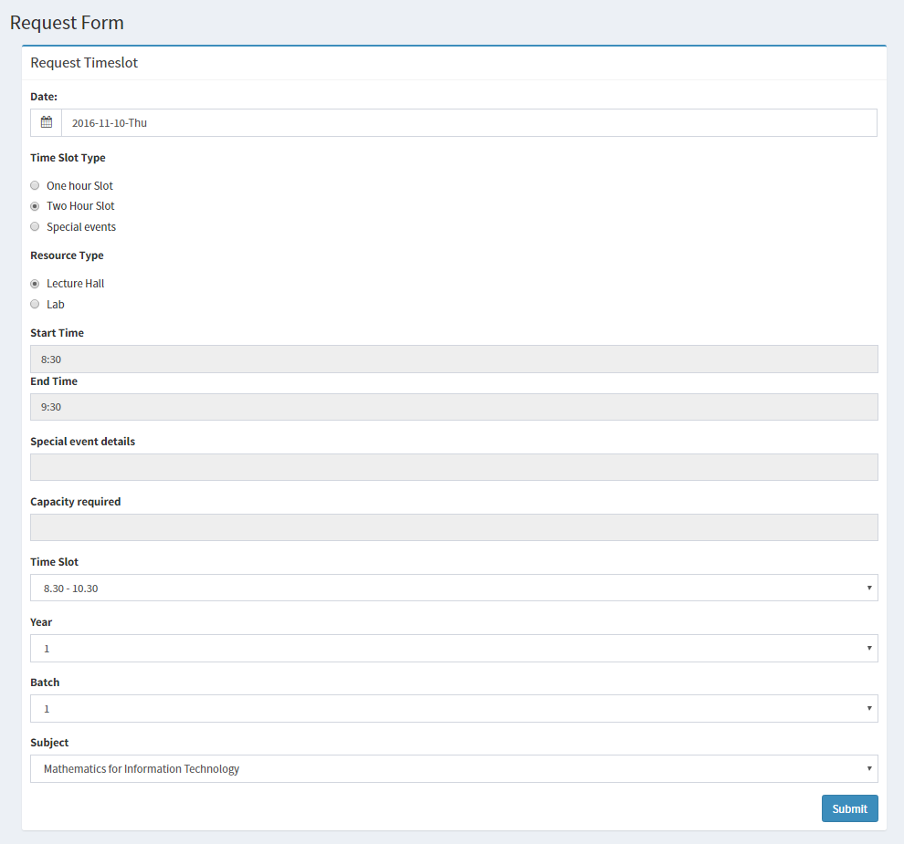

1. Select the Year, Batch and the subject.
2. Click ‘*Submit*’ to submit the form.

Once you submit a request it will be added to your ‘Academic Requests’ table. And once an Administrator approves it will be moved to ‘Accepted Academic Requests’ table.

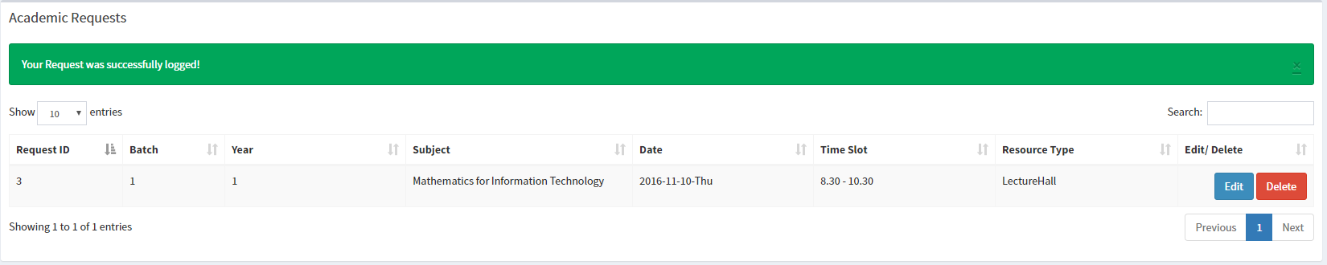

### Editing a Formal Request

You can only edit the request until the administrator approves the request.

1. Click ‘*Edit*’ on the entry you want to edit.
2. Press ‘*Yes*’ on the alert message to confirm your choice.
3. Change the required details.

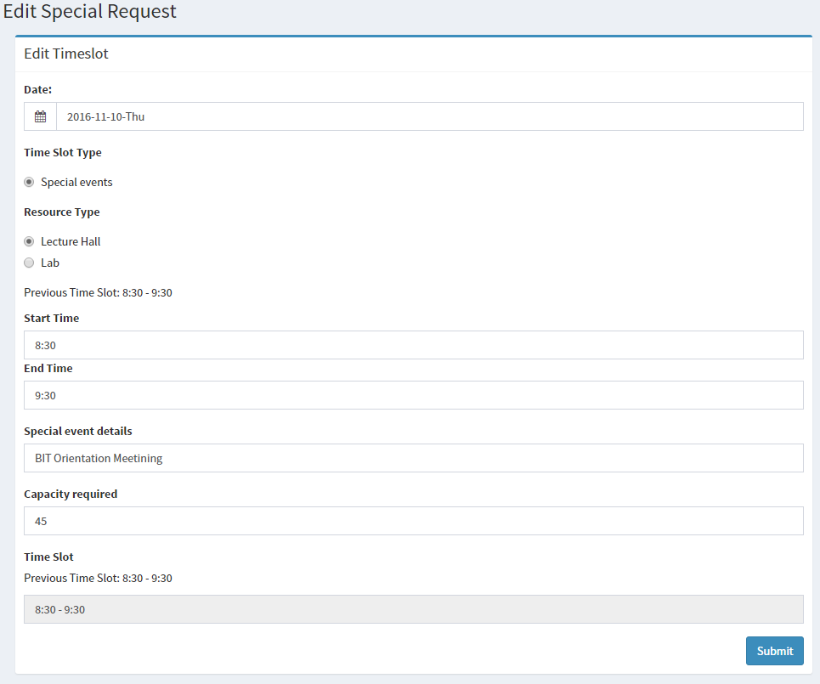

1. Click ‘*Submit*’.

### Deleting a Formal Request

1. Click ‘*Delete*’. On the record you want to delete.

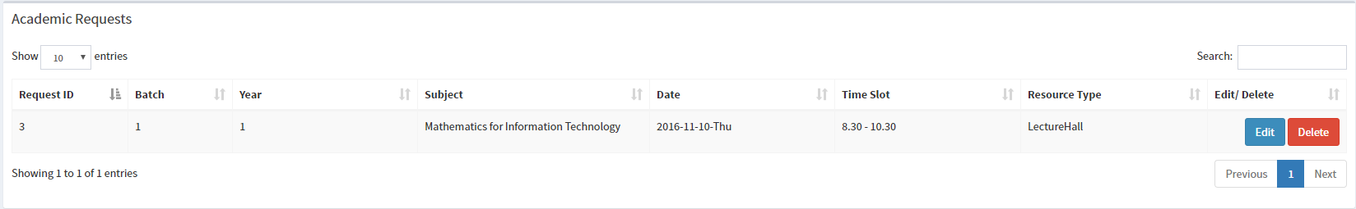

1. Click ‘*Yes*’ to confirm the choice.

### Adding a Special Request

1. Click ‘*More info*’ under Requests section.
2. Fill the form with ‘Special Events’ selected.

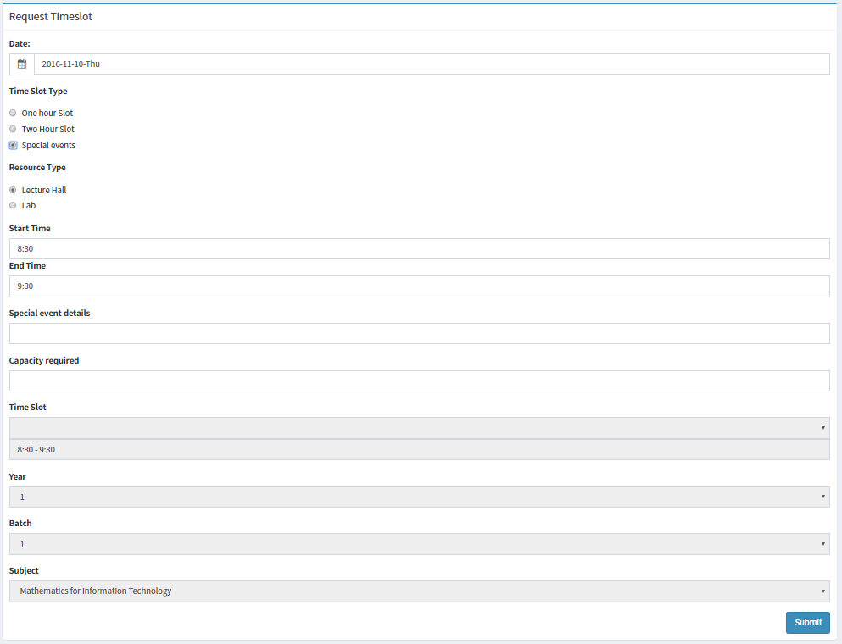

1. Fill the details and capacity required with the expected date.
2. Click ‘*Submit*’ to submit the form.

Once you submit the form your entry will be added to ‘Special Event Requests’ Table. Once your requests have been approved your entry will be moved to Accepted Special Event Requests’ Table.

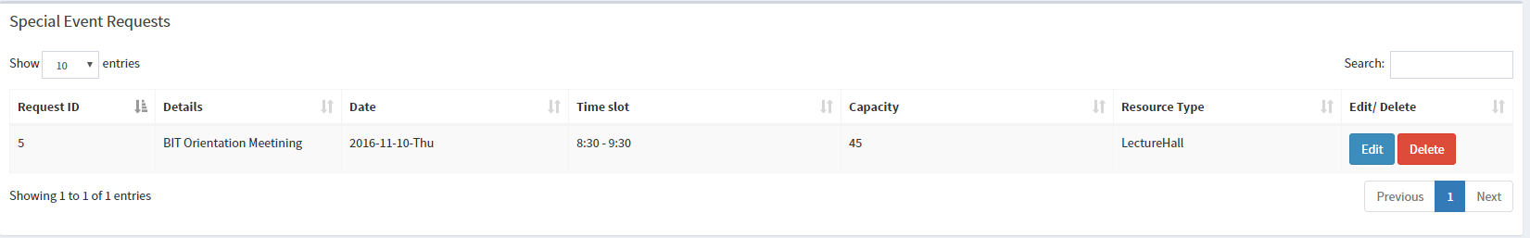

### Editing a Special Request

You can only edit the request until the administrator approves the request.

1. Click ‘*Edit*’ on the entry you want to edit.
2. Press ‘*Yes*’ on the alert message to confirm your choice.
3. Change the required details.

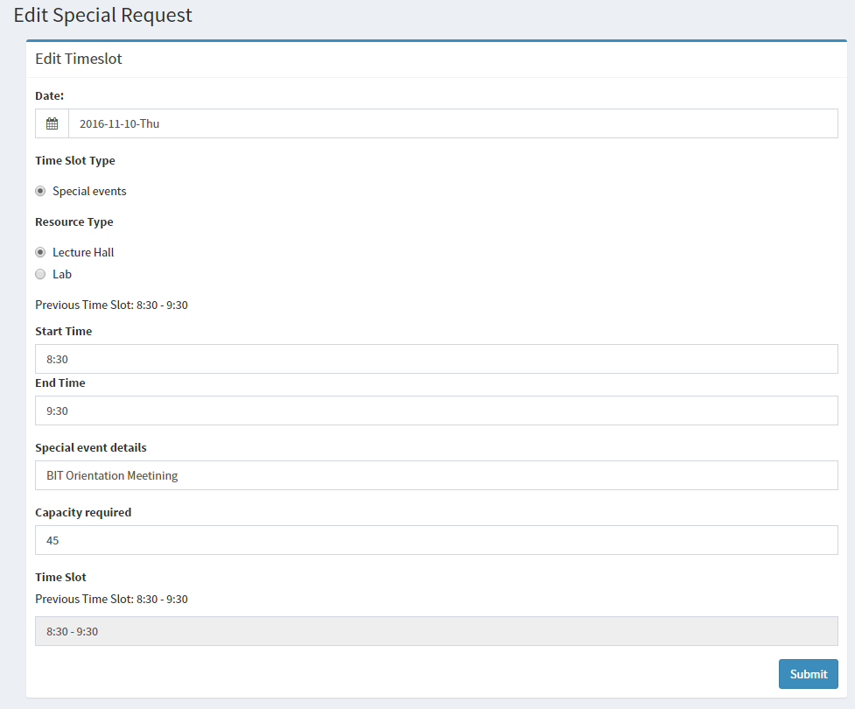

1. Click ‘*Submit*’

### Deleting a Special Request

1. Click ‘*Delete*’. On the record you want to delete.



1. Click ‘*Yes*’ to confirm the choice.

### Adding a Semester Request

Semester requests can only be added once the administrator enables the form.

1. Click ‘*More info*’ under Semester Requests.
2. Fill the form with the semester, time slot, year, batch and subject for requesting date.

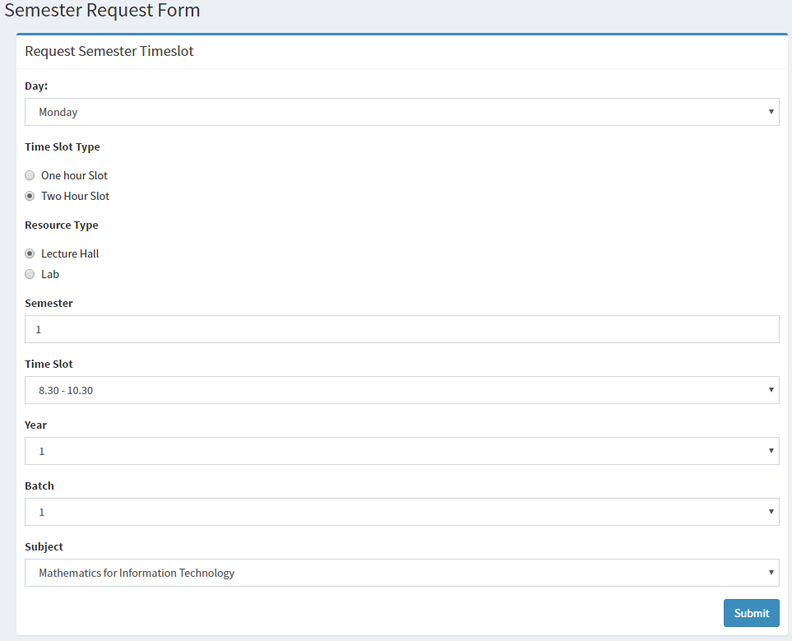

1. Click ‘*Submit*’.

Once you submit the form your entry will be added to ‘My Semester Requests’ Table.

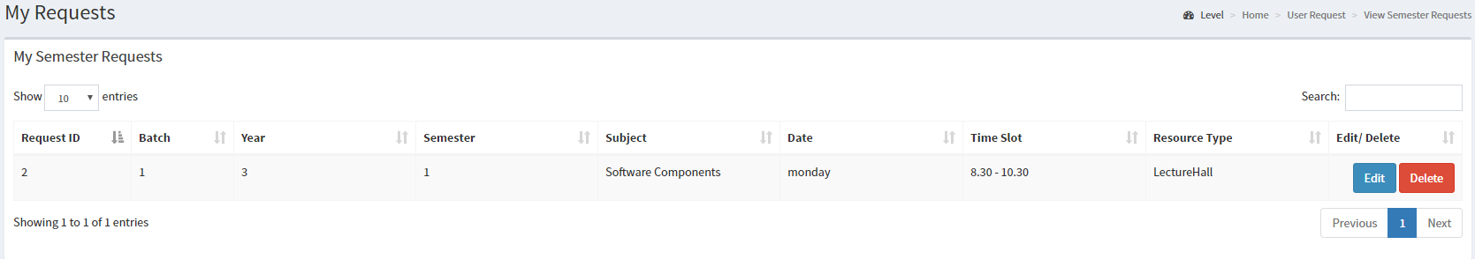

### Editing a Semester Request

You can only edit a semester request before the deadline.

1. Click ‘*Edit*’ on the entry you want to edit.



1. Press ‘*Yes*’ on the alert message to confirm your choice.
2. Change the required details.

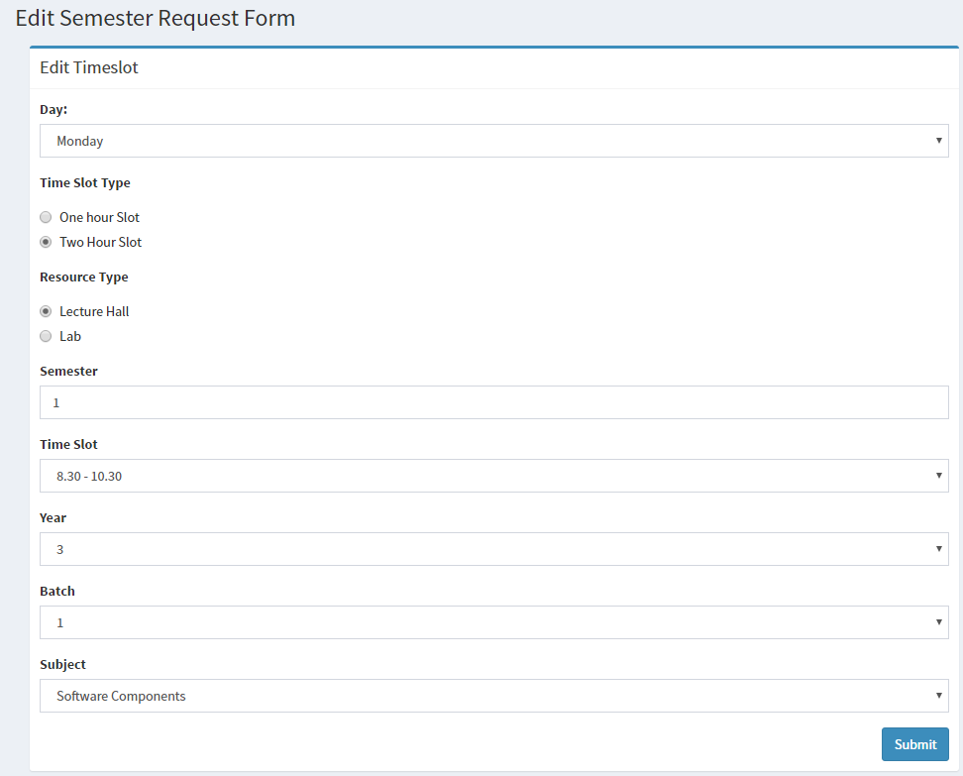

### Deleting a Semester Request

You can only delete a request you have placed until the administrator approves it.

1. Click ‘*Delete*’. On the record you want to delete.



1. Click ‘*Yes*’ to confirm the choice.

### Viewing Requests.

1. Click ‘*More info*’ under My Requests.

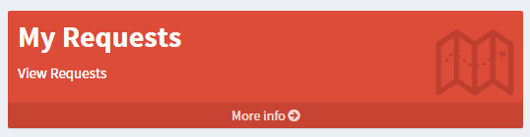

You can view all your requests under viewing section.

## Timetable

You can view your timetable where all the allocations of subjects will be displayed.

### View Timetable

1. Click ‘*More info*’ under My Timetable.



Once you visit the timetables page you will be displayed with your timetable.

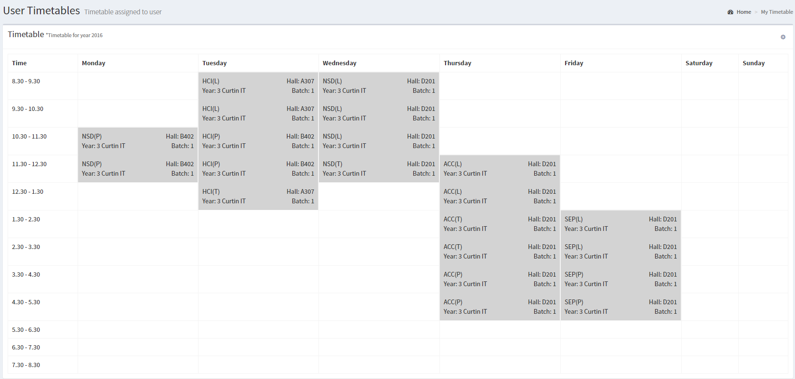

### Exporting Timetable as Excel Sheet

1. Click ‘*More info*’ under My Timetable.
2. Click the ‘Gear’ icon and click ‘*Export excel*’.

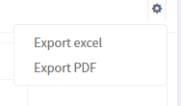

### Exporting Timetable as PDF

1. Click ‘*More info*’ under My Timetable.
2. Click the ‘Gear’ icon and click ‘*Export PDF*’.



# Chapter 03: Advanced Guide

This guide is to help the administrator to carry out the advanced tasks such as assigning deadlines, enabling semester request form for normal users, managing database backups, resetting databases.

Administrator settings can be accessed by clicking ‘*Administrator Settings*’ in the left side pane.

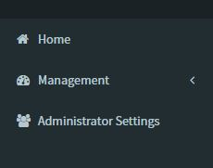

## Assign Deadlines

### Add a Deadline

1. Enter Year, Semester, Date in the form assigned for Deadline Management.

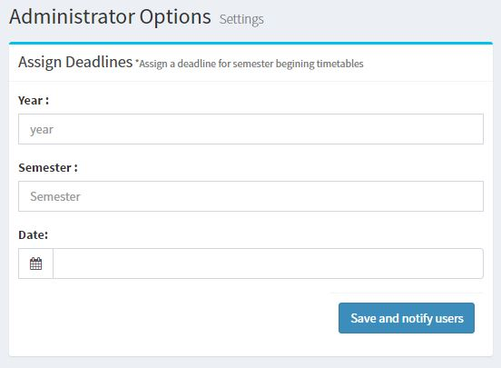

1. Click ‘*Save and notify users*’.

Once the user adds a deadline it will be shown in the Deadlines table.

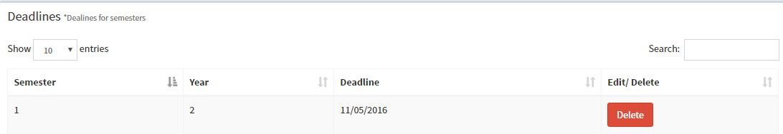

Note that this will send an Email to every user in the system asking them that the deadline for the particular year and semester is the assigned date in the form.

### Delete a deadline

1. Click ‘*Delete’* button of relevant to record.



1. Click ‘*Yes’* on the alert message.

## Options

In the options section you can perform high level administration tasks such as database backups and resets.

### Enable Semester Request form

1. Put a tick on the checkbox to enable the semester requests form under the ‘Options’ box.

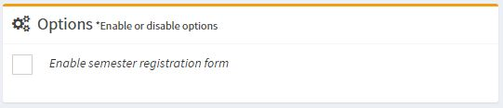

1. Click ‘*Yes*’, in the notifications box.

This will make the semester requests form visible for the normal users.

To disable the semester request form simply untick the checkbox and the semester form will no longer be active or visible to the normal user.

### Completely Clear Timetable

This will completely erase all the data regarding timetables and requests for both formal and semester requests.

1. Click ‘*Clear Timetable*’ under the Database Operations box.

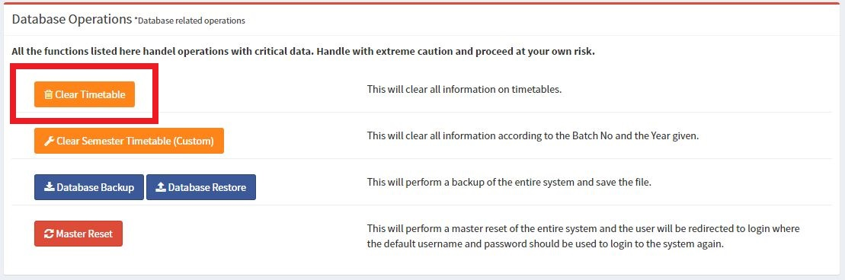

1. Click ‘*Yes*’, confirming the selection.
2. Enter the administrator login password and click ‘*Yes*’.

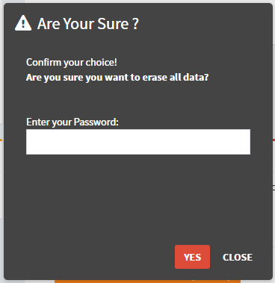

### completely Clear Timetable (Custom)

This will erase all the data regarding timetables, requests and semester requests according to the values user specifies.

1. Click ‘*Clear Semester Timetable (Custom)’* under the Database Operations box.

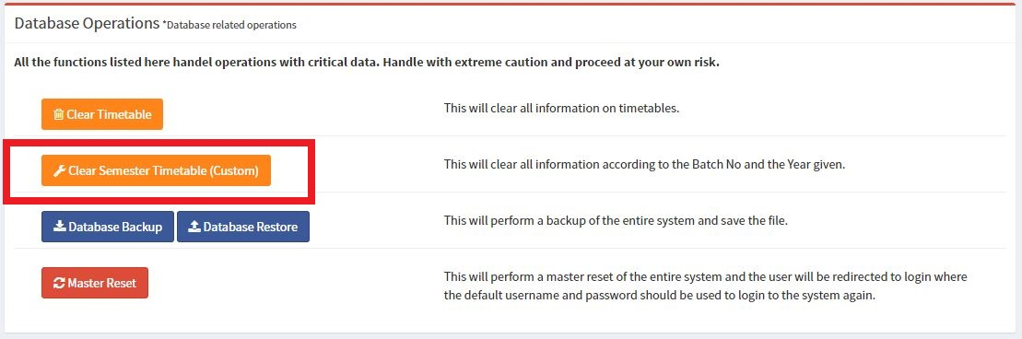

1. Enter a Year, Batch no and select the type of operation you want to perform.

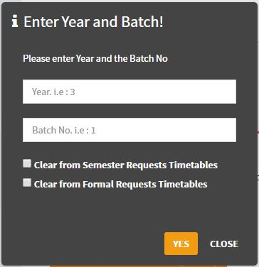

1. Click ‘*Yes*’, confirming the selection.
2. Enter the administrator login password and click ‘*Yes*’.

### Database Backup

This will perform a complete backup of the entire system and provide an sql.gz file which only can be used on this application.

1. Click ‘*Database Backup*’ under the Database Operations box.

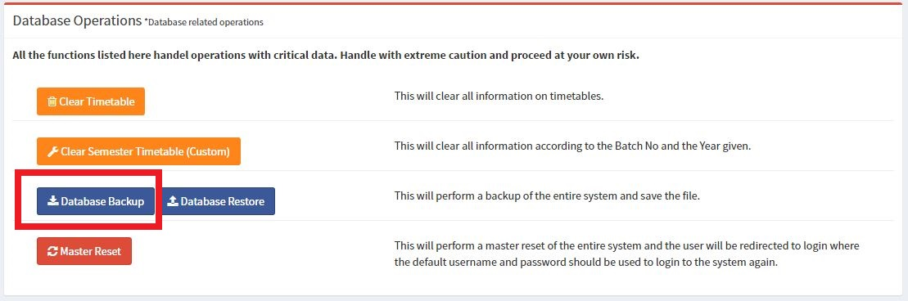

Once you click on the database backup button a file will be prompted to download.

### Database Restore

This will let the user import a previously produced sql.gz file which could be used to restore the systems database. Restoring from a file may completely erase any previous data already in the system.

1. Click ‘*Database Backup*’ under the Database Operations box.

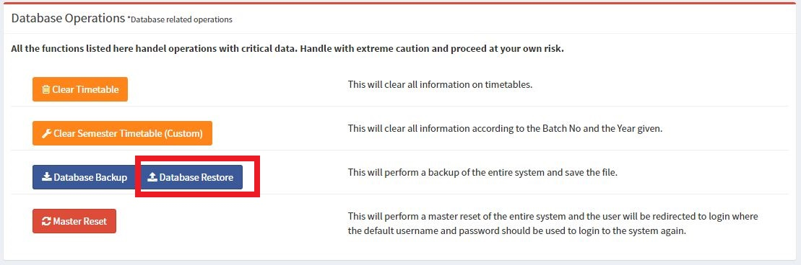

1. Select and upload an sql.gz file.

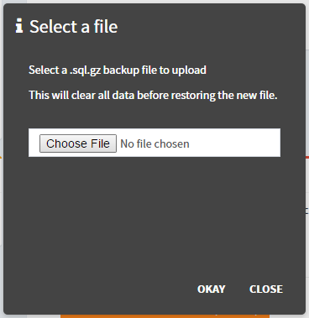

1. Click ‘*Yes*’, confirming the selection.

### Master Reset

This will completely erase all the information stored in the system and completely reset the system in to its initial state. Performing this action will automatically end the users’ session and redirected to the login page where the user will have to use the default administrator login information to login to the application.

1. Click ‘*Master Reset*’ under the Database Operations box.

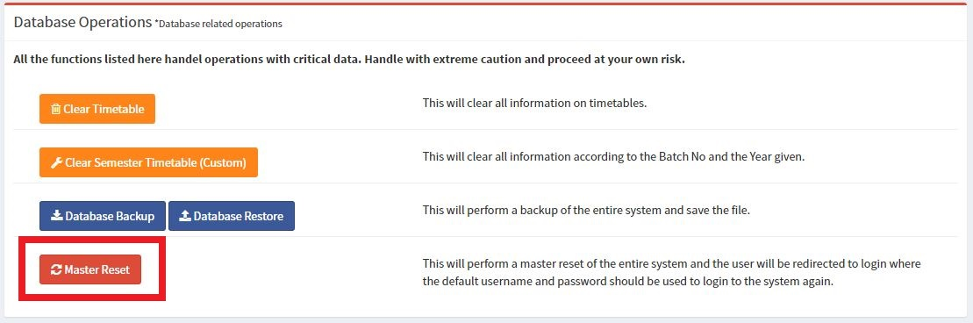

1. Click ‘*Yes*’, confirming the selection.

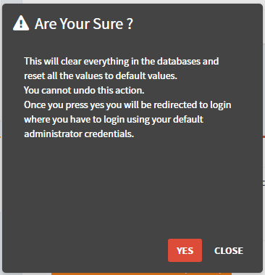

1. Enter the administrator login password and click ‘*Yes*’.

